
NAME: BISMA FATIMA
CLASS: CS A
ROLL NO: F24605036
COURSE: INFORMATION SECURITY
COURSE CODE: CS-291
LECTURER: MISS ATTIA ASHRAF

LAB 04

Installation
- ∙ Tcpdump is generally pre-installed on most Linux systems.
- ∙ If it’s not installed, you can install it with the following command:
sudo apt update && sudo apt install tcpdump
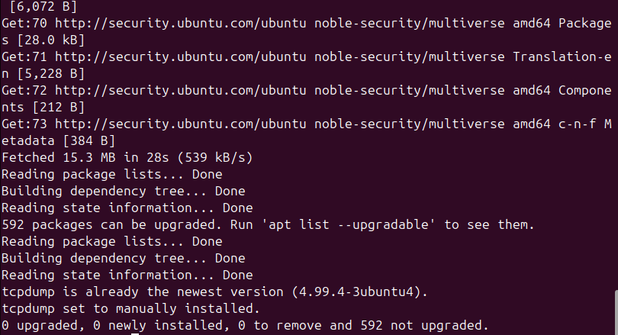

Lab Submission Requirements
1. Screenshots:
- Include screenshots of captured traffic for each activity.
- ∙ Identify available network interfaces:
ip a

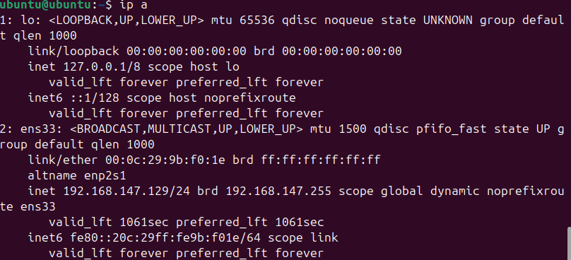

Activity 1: Basic Packet Capture
✅ What to Do:
- Run tcpdump to see all network packets in real time.
- Use:
sudo tcpdump -i <interface>
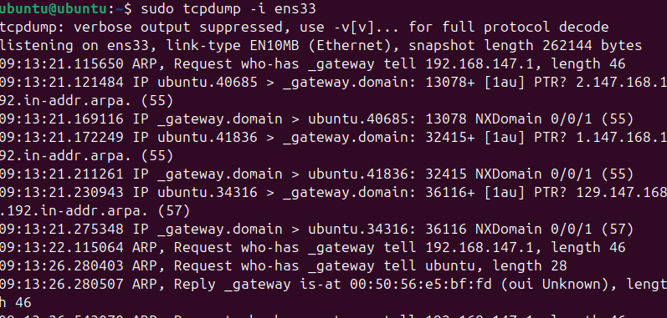

What to Look For:
- Source and destination IP addresses
- Source and destination ports
- Protocol used (TCP, UDP, ICMP, etc.)
- Packet size and timing
📝 Analysis:
- You’ll see a mix of traffic types: DNS queries, HTTP requests, ICMP pings, etc.
- Note any unusual IP addresses or ports—these could indicate unknown devices or suspicious activity.
- This helps build a baseline of normal traffic for future comparison.

Activity 2: Filter by Protocol
✅ What to Do:
Capture only specific types of traffic:
- HTTP (web traffic):
sudo tcpdump -i <interface> port 80
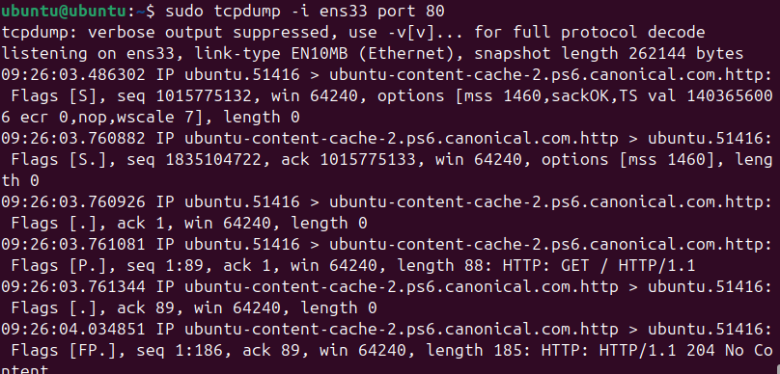
- ICMP (ping):
sudo tcpdump -i <interface> icmp
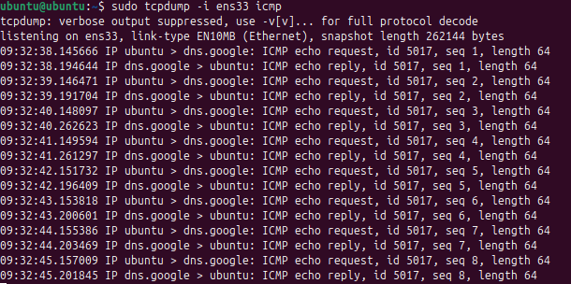
- DNS (domain name lookups):
sudo tcpdump -i <interface> port 53
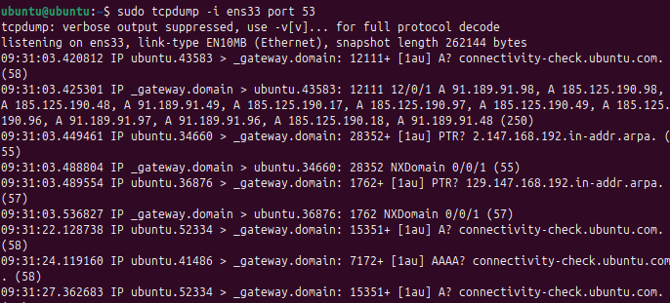

🔍 What to Look For:
- ICMP: Shows ping requests and replies—used for connectivity checks.
- HTTP: Displays HTTP headers, methods (GET/POST), and hostnames.
- DNS: Reveals domain name queries and responses.
📝 Analysis:
- ICMP packets are simple and show basic connectivity.
- HTTP packets contain more detailed info like browser type and requested URLs.
- DNS packets show which domains are being resolved—useful for tracking browsing behavior.
- Comparing protocols helps understand how different services communicate.

Activity 3: Filter by IP Address
✅ What to Do:
Capture traffic from or to a specific IP:
- From IP:
sudo tcpdump -i <interface> src <IP_ADDRESS>
- To IP:
sudo tcpdump -i <interface> dst <IP_ADDRESS>
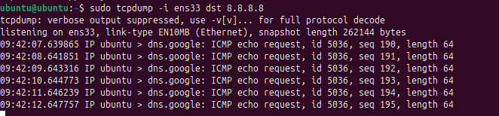
- Both directions:
sudo tcpdump -i <interface> host <IP_ADDRESS>
What to Look For:
- Only traffic to/from the specified IP will appear.
- Useful for monitoring a specific device or server.
📝 Analysis:
- Helps isolate traffic for one machine—great for troubleshooting or auditing.
- You might notice repeated connections, large data transfers, or unexpected destinations.
- Can reveal malware communication or unauthorized access attempts.

Activity 4: Advanced Filtering
✅ What to Do:
Use more specific filters:
- SYN flag (connection attempts):
sudo tcpdump -i <interface> 'tcp[tcpflags] & tcp-syn != 0'
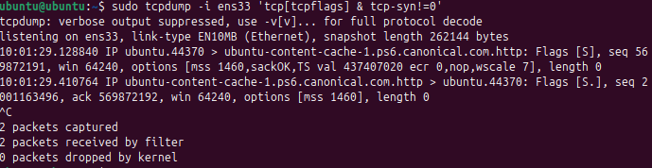
- Subnet traffic:
sudo tcpdump -i <interface> net 192.168.1.0/24
- Large packets (>1000 bytes):
sudo tcpdump -i <interface> 'tcp and greater 1000'
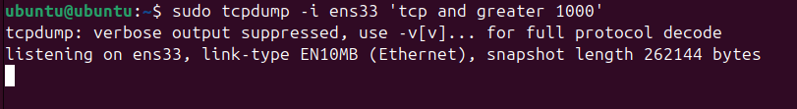
🔍 What to Look For:
- SYN packets show devices trying to start a connection.
- Subnet filter shows all traffic within your local network.
- Large packets may indicate file transfers, video streams, or suspicious data exfiltration.
📝 Analysis:
- SYN filtering helps detect port scans or brute-force login attempts.
- Subnet monitoring is useful for internal network audits.
- Large packet detection can flag heavy usage or potential data leaks.

2. Explanation of Findings:
- Provide brief explanations for the traffic patterns observed.
ANS:
Traffic Patterns Observed: During the packet capture, regular traffic such as DNS queries, HTTP requests, and ICMP ping packets were observed. These patterns reflect typical user activity like browsing websites, accessing services, and network diagnostics.

- Describe any notable packets or activities, including potential security concerns.
ANS:
Notable Packets or Activities:
- ICMP packets indicated ping requests, useful for checking connectivity.
- HTTP packets revealed header information, including hostnames and user agents.
- DNS queries showed domain lookups, which can help identify which websites or services are being accessed.
- Potential Security Concerns:
  - Repeated SYN packets without ACKs could suggest a port scan or SYN flood attack.
  - Unfamiliar IP addresses or traffic to unexpected ports might indicate unauthorized access attempts or malware communication.

3. Reflection on Tcpdump Usage:
- Reflect on how Tcpdump could be used in real-world scenarios, especially for network troubleshooting and security monitoring.
ANS:
- Real-World Applications:
  - Network Troubleshooting: Tcpdump helps identify connectivity issues, dropped packets, or misconfigured devices.
  - Security Monitoring: It can detect suspicious traffic, unauthorized access, or signs of attacks like DoS, spoofing, or data exfiltration.
  - Performance Analysis: By examining packet sizes and timing, admins can spot bottlenecks or overloaded services.
- Why It’s Valuable: Tcpdump provides raw, real-time visibility into network behavior, making it a powerful tool for both proactive monitoring and reactive investigation.

4. Conclusion:
Summarize key takeaways from the lab and the importance of network traffic analysis in cybersecurity.
ANS:
Key Takeaways:
- Tcpdump is a versatile and powerful tool for capturing and analyzing network traffic.
- Filtering by protocol, IP address, and packet characteristics allows for targeted analysis.
- Understanding traffic patterns helps identify normal behavior and detect anomalies.
- Network traffic analysis is essential in cybersecurity for detecting threats, ensuring compliance, and maintaining system integrity.
Importance in Cybersecurity: Tcpdump empowers professionals to uncover hidden threats, validate security controls, and respond swiftly to incidents—making it a cornerstone of any robust cybersecurity strategy.

